Git Guide

Ian Perez Bunuel

# git init

git init is used to create an empty repository in the folder where you have started Git bash.

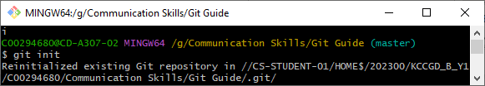

# git status

This command will show you what is on the stage and what is not. It will tell you if it was modified, deleted, ext.

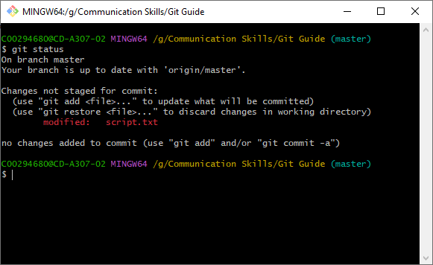

# git add

git add . – this command will add every file in the repository to the stage. Instead of . you can type in the file name after the dot to specify which one you want to add.

This shows the files that were added using git status:

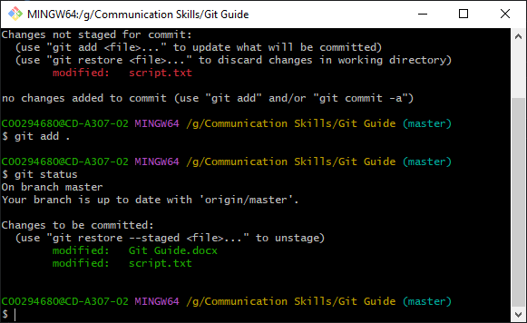

# git commit

git commit is used to put all the files in the staging area into a node. This node should have a note which is done by adding -m “note” after the git commit command.

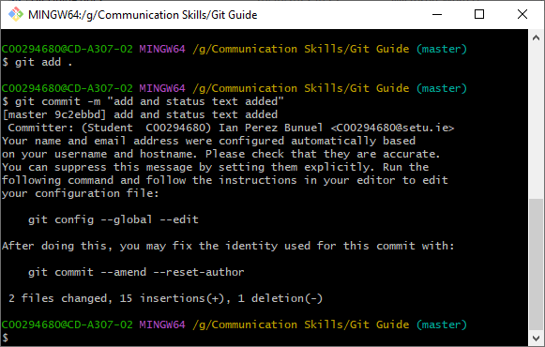

# git push

git push puts nodes done by commit into the online repository. The command is: git push -u origin master – master is the name of our default branch which is the one we want to push.

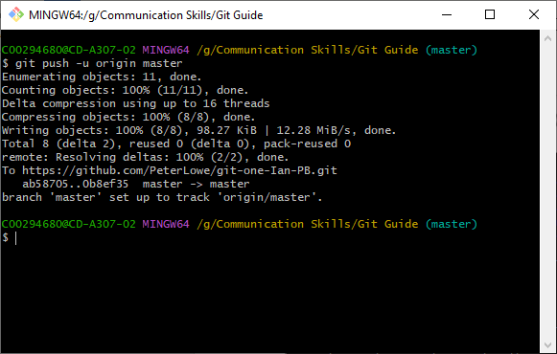

# git remote

git remote – list repositories on remote server.

git remote add <name> <url> - creates a new remote repository.

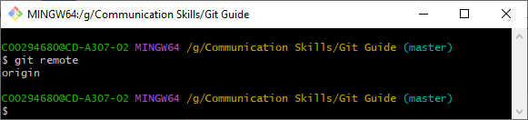

# Git branch

Git branch newBranchName : Creates a new branch in the local

repository.

git branch –a / -l / -r : Lists branches in repositor

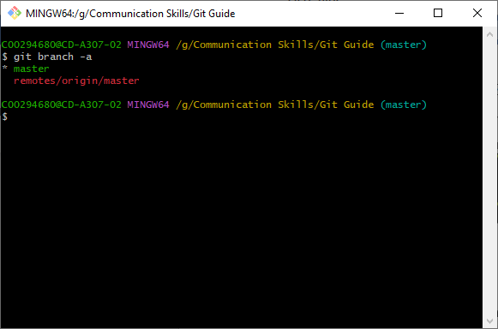

# git checkout

Command: git checkout branch_name

Makes this node the current Head

It won't work if there are modified files.

Use –f to discard non committed files.

# git merge

git merge branch_name - This will merge the named branch with the current branch.

(this is an example of trying to merge when they are the same)



# git log

• git log – shows the entire commit history

• <space> shows the next page

• <q> quit

• git log --stat – Files altered, and line changed

• git log --graph – Branch paths drawn

• Git log --graph –oneline – Draws path condensed output

• Git log --n – Only last n commits.

(git log)

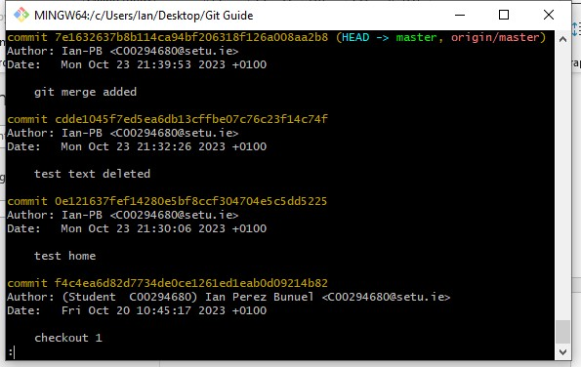

(git log --stat)

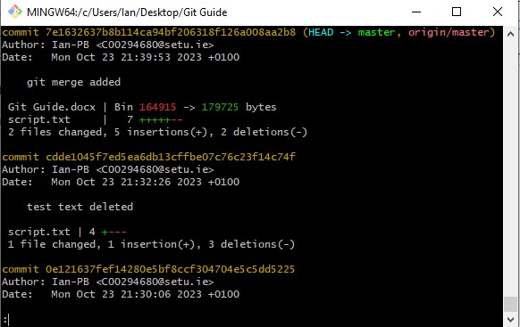

(git log --graph)

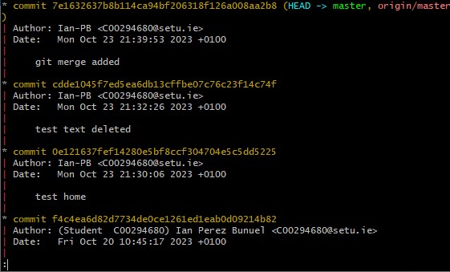

(git log --graph --oneline)

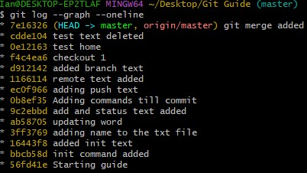

(git log --n)

# git pull

• git pull <remote> - Perform a fetch and merge

• git pull –rebase – Perform a fetch and merge the remote origin into

my local master

# Git stash

• git stash – creates a local only copy of the current working directory

• git stash list – list previous stashes

• git pop – retrieve the stash{0} and copies the file to working directory

• git apply stash{1} retrieve stash{1} and copy into the current directory

